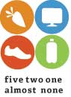
HEALTHY SNACK IDEAS

In order for your child’s energy and brain power to be sustained throughout the day, snacks are an important part of their day. Parents are often asked to provide snacks during school and after sporting events. Please be thoughtful about what you provide. If the snack is filled with artificial flavors and colors, and is high in fat and sugar, it may slow your child’s ability to succeed.

We encourage you to choose snacks from the following items:

Pretzels 1/2 bagel or bagel bites Rice Cakes Low-fat Popcorn
Animal Cracker Teddy Grahams Graham Crackers
Nutri-Grain Cereal Bars

FRUIT
Fresh is best! (fresh, canned or dried)
Bananas (cut in half), Apple slices, Orange slices, Grapes
Canned fruit packed in its own juice can be super easy and reasonably priced!

RAW VEGETABLES
Celery with peanut butter, broccoli or carrot sticks
with a low-fat dip are great choices

LOW SUGAR CEREALS
Cereals which do not contain any artificial flavors or colors

BEVERAGES
The best choice is water! Juice should be 100% fruit juice and should be limited to small amounts (4-6 oz.) due to the amount of sugar per serving!
1 % or skim milk is also a good choice!

Our recommendation for best choice snacks includes foods and beverages that furnish per serving: less than 200 calories, 30% or less fat, 35% or less sugar, less than 480 mg sodium, and at least 10% of one of the following nutrients, Vitamin A, Vitamin C, Calcium, Iron, fiber and Protein.

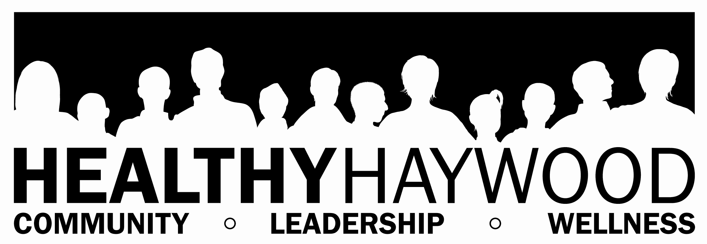

2177 Asheville Road  Waynesville, NC 28786  Phone: 828.452.6675  Fax: 828.452.6730

● www.healthyhaywood.org 

A Certified Healthy Carolinians Partnership & A Haywood County Health Department Program
This list was created by Healthy Haywood’s Obesity Prevention Action Team.

