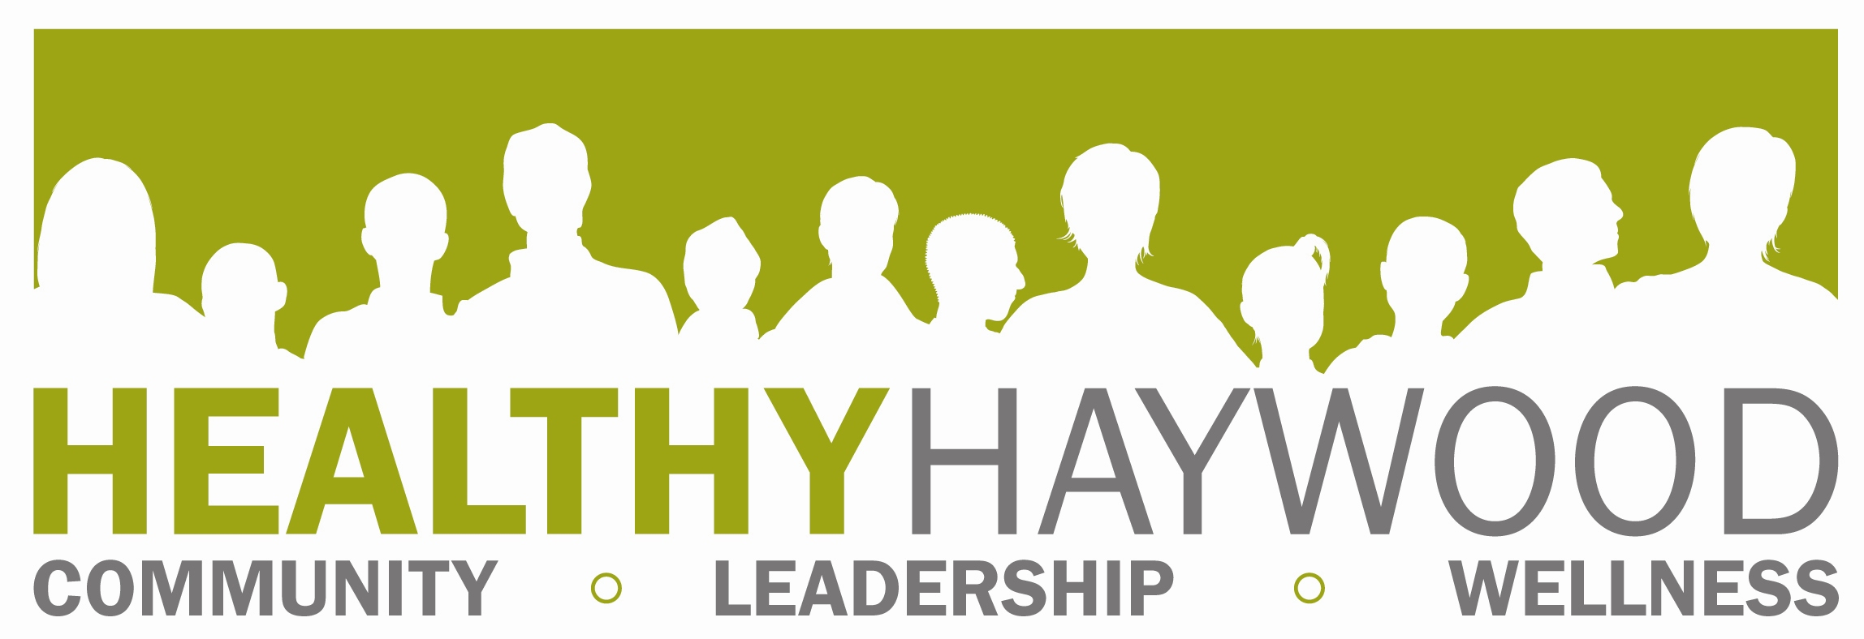

Full Partnership Meeting
Thursday, June 5, 2014, 2 p.m, DSS Training Room
Minutes taken by: Megan Hauser
In attendance: Chris Watras, Michelle Mathews, Paul Turner, Anita Wilkins, Patti Tiberi, Rachel Smith, Nancy Bauman, Mike Simonson, Megan Hauser

- WELCOME & INTRODUCTIONS
- OLD BUSINESS
  - Review of May minutes
    - Motion to approve minutes- Paul Turner
    - Second- Michelle Mathews
- NEW BUSINESS
  - Project Updates
    - Fitness Finder
      - Some updates have been turned in; Megan has been inserting these and making additional changes. We will print as many as the Fitness Challenge budget allows (other purchases to make: FC promotional materials and mini-grants)
    - Encouraging Providers to Use Controlled Substances Reporting System
      - Legislation- this is a short session, so action is unlikely. During the first attempt, the bill was introduced, passed the 1st reading and went to a subcommittee.
      - Local Efforts- Dr. Paschal continues to encourage the use of this by MedWest Haywood prescribers. Prescribers can designate someone in their office to look up a patient in the CSRS (ex. - nurse).
    - Training for Health Care Providers on Proper Opioid Prescribing
      - Meeting scheduled for family medicine prescribers- Dr. Paschal, Dr. Martin and Dr. Holmes will speak. They will address guidelines for prescribing opioids for chronic non-cancer pain, recognizing patients with opioid use disorder and how to refer those patients to an addiction specialist. Chief Hollingsed will talk about safeguarding opioid prescriptions. After this meeting, a group of Physicians for Responsible Opioid Prescribing (PROP) will form.
    - Alcohol and Tobacco Projects
      - Sticker Shock- 1st time in Haywood County…success! Stickers were placed on alcoholic beverages Ingles and Mountain Energy. Students placed stickers on ABC store bags (did not enter store due to age). Paul will help Patti work on better relationship with Budweiser for next project. Next sticker shock project will be in April (Alcohol Awareness Month).
      - Underage Drinking Forum- excellent discussion between youth and panelists. Poor turnout from general public. Concern that this wasn’t a wise use of speakers’ time.

    - How to better publicize events- need to have standard approach to publicizing all events. Will work to publicize each event/program using the following methods. Please let Megan know if you have further ideas.
      - County channel- Haywood County TV
      - County website
      - Newspapers- The Mountaineer AND Smoky Mountain News
      - Healthy Haywood Facebook page
      - HH website
      - Google group
      - Flyers/bulletin boards
      - E-mail (Healthy Haywood partner listserv, county employees, etc).
    - Involve steering committee more in all coalition activities.

  - Other Coalition Updates
    - 5-2-1-Almost None Initiative- partnered with Girls on the Run (hosted table)
      - Approximately 1400 people attended event (volunteers, runners, spectators)
    - Breast Cancer Forums
      - Poor attendance. Suggestion made to partner with a treatment provider (already has audience; vulnerable populations).
    - North Carolina Coalition Initiative grant application: $27,700
      - Will be able to hire part-time coordinator
      - Small group of coalition members, including grant coordinator, will attend workshops by NCCI/Community Anti-Drug Coalitions of America. First training (web/phone) is soon and all coalition members can attend- Megan will send announcement.
    - Project Lazarus Funding (projects and budget adjustments)- contact Megan if you would like any of the printed materials listed below.
      - Tip line flyers available
      - Rx bag flyers available- feel free to use for events, etc.
      - Rx drug drop-off event flyers- somewhat blank so we can customize them for various events; will fill in details and share them with our law enforcement agencies to promote events.
      - Posters to promote drug drop-off sites
      - Additional lock boxes ordered (15)- will be provided to Waynesville Police Department
      - Cases ordered for officers to carry Naloxone/Narcan (92 cases; will cover most officers/all patrol officers)
    - Prescription for Safety Rescue Project (May meeting update)
      - No additional updates on policy (EMS was unable to join us for meeting)- policy will be reviewed by county EMS director, state EMS director, attorneys of any law enforcement agency wishing to participate (Megan will check with EMS for updates).

AGENCY UPDATES/ANNOUNCEMENTS
WNC Teen Institute will hold Summer Teen Institute
NEXT MEETING & REMINDERS: Thursday, August 7, 2-4 p.m., DSS Training Room at Haywood County Health and Human Services Agency

