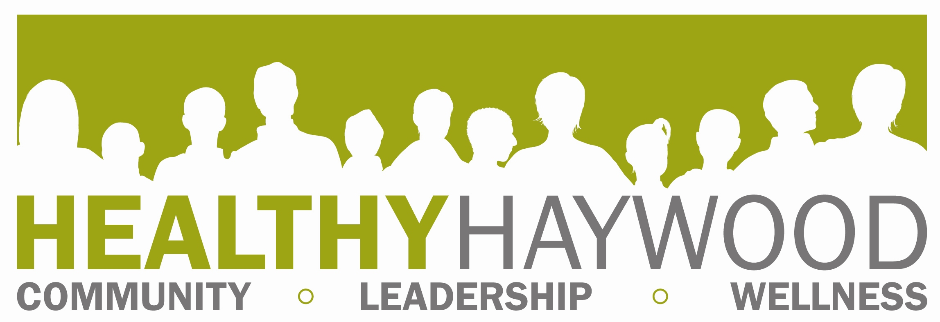

Full Partnership Meeting Minutes, Thursday, November 20 2014, 2 p.m., Environmental Health Conference Room

Present: Anita Wilkins, Montez Lane and Nicole Augustine (NCCI), Rachel Smith, Jean Parris, Chief Bill Hollingsed, Lt. Don Robertson, Ray Brown, Julie Sawyer, Nancy Bauman, Megan Hauser, Alison Francis, Michelle Mathews, Susan Kimball, Patti Tiberi, Georgia Raines, Paul Turner

Minutes by: Megan Hauser

- WELCOME & INTRODUCTIONS

- OLD BUSINESS
September Minutes- motion made to approve by Paul Turner; second made by Rachel Smith

- NEW BUSINESS
  - North Carolina Coalition Initiative Grant- Welcome!
    - NCCI explanation by grant staff
      - Montez Lane- oversees training and technical assistance; Nicole Augustine is our technical assistance provider.
      - Two year grant, 1st year is planning and data collection; 2nd is implementation (environmental and policy change). This grant builds coalition capacity. Grant is through Wake Forest University. NCCI works Anuvia, East Carolina University, UNC-Greensboro, Unlimited Success, Community Anti-Drug Coalitions of America.
      - We are making a logic model. Important to have diverse coalition. Have evaluation component.
      - For trainings- NCCI pays for two to go. We can take more through our grant funds. Helps members learn about NCCI process. We’re stepping back to collecting data; we’re learning about sustainability and engagement. We have TA webinars after trainings (coalition members can attend). NCCI benefits: sustainability, can help us get more funding (Drug-Free Communities; 125 K yearly for 5 years).
    - Data collection
      - Working with college on survey. Focuses on unmet health needs; college may provide health care services on campus. Topics include substance abuse and exercise. Survey is through student e-mail (Survey Monkey).
      - Resident survey- shared with coalition members/staff, etc. Questions address Rx drugs, which are easiest to get, etc. We’ve had a great response.
      - Other options: focus groups and listening sessions.
      - Also need law enforcement data; thanks to WPD and HCSO for being involved.
    - Coordinator- will be hiring part-time person; need someone in mind for when we can advertise (please make suggestions). Megan is the main contact person.
  - Mountain Projects grant application- Project for Success
    - Federal funds through DHHS. Focus is Rx drug abuse with 12-25 year olds. HCC and Dr. Garrett are allowing surveys (MS and HS). Need letters of support. Due on December 8. Will hire full-time person. Interventions will be at environmental and population levels. Applicants will be notified on 12/17. Will engage parents and support kids to do programming in schools. Will start in January. Funded through 2016, possibility of 2 more years. Worth $100,000. Will study past 30 day and lifetime usage, availability of substances, perception of harm. Focuses on opiates and stimulants.
  - Drugs in Our Midst
    - Prayer walk- downtown Waynesville, two prayers held at each downtown churches, the soup kitchen and historic courthouse. Bigger crowd (500) people. DARE car an bike police were involved.
    - Local presentations- have strong personal testimony, big law enforcement involvement (Bill, Greg, drug detective). Mostly held in churches (space reasons). Shelton Laurel program went great and had lots of kids. Programs address Rx and illegal drugs. Can speak at civic presentations, conferences (length can be edited).
    - ALC and CHHS presentations have been held; first time in schools. DIOM will go to Pisgah for a day (Richie Tannerhill and Bill Hollingsed will speak).
  - Law enforcement and legislation- local officers have helped pass statewide bills, most are about Rx drugs. The law about mandatory use of the Controlled Substances Reporting System didn’t pass (doctors can designate staff person to pull info). Senator Davis will reintroduce CSRS bill (some physicians are willing to testify). Physicians for Responsible Opioid Prescribing is going. Pharmacists now have to enter Rx within 72 hours. There is legislation about illegal medicine substitutions. Synthetic substances are now illegal. Trying to address overprescribing. PROP working with NC Medical Board about prescribing criteria. Hydrocodone now 2 instead of 3. Congressman Meadows sponsored bill. Tramadol is 4 instead of unscheduled. Drug arrests have increased with Sheriff’s Office. Law enforcement agencies are working more closely (ex.- task force). .
  - Drop boxes- at all law enforcement agencies, emptying several times a week. Lock boxes being installed in homes. Working to have law enforcement carry Narcan; we do have $ coming (could potentially use it to buy medicine).
  - Fitness Challenge: we had 878 participants, more vendors, programs for kids. Good closing eveng. Have prizes left and are working to distribute remaining ones.
  - Fitness Finder- it is now available and we also have it in PDF so members can reprint. Thanks to those who helped with updates.
  - Power of Pink Update- There were fewer people than last year, but more funds have been raised ($19,000). Money helps with screenings/mammograms, may help with transportation. Our agency benefits from it. We help women who are uninsured/underinsured. Thank you for volunteers (this allowed us to also do NCCI survey collection).
  - Community workshops
    - Town of Waynesville employees (11/21) - will focus on ‘’Maintain, Don’t Gain Holiday Challenge.’’
    - Head Start- Anita giving presentations to parents. Talks include 5-2-1-Almost None.
    - Clyde Elementary- girls empowerment night; hygiene, healthy eating, 521AN/sugary drinks/healthy plates; worked with 3-5th grades.
  - WNC Healthy Kids grant- Alison Francis, Megan Hauser, Melissa Rockett are applyingl worth $1,000.
  - American Cancer Society Partnership- working on a resource guide (soup kitchens, SA treatment, thrift stores, etc). Program is called Community Network Partnership. Have been focusing breast cancer, expanding to colorectal cancer. Also recruiting Community Health Advocates (CHA’s educate people and guide them to screenings. Some women have indicated interest in volunteering. Potential March program- ‘’shop talk,’’ program where barbers educate clients about colorectal cancer screenings.

- AGENCY UPDATES/ANNOUNCEMENTS
- Article about lung cancer in paper (features Dr. Skibo).
- Mike has gotten new members from the Fitness Challenge
- Michelle- still converting systems at DSS, crisis intervention heating applications coming in.
- Julie- will be teaching Eat Smart, Move More, Weigh Less classes in the new year.
- Alison- planning for summer feeding program, trying to expand. Many students (53%) on free/reduced lunch. Want to pilot sites in Waynesville and Canton areas, must be places where kids can walk. Volunteers needed to staff sites. Kids ages 2-18 can come. Areas with HUD housing would be ideal (Ninevah area suggested).
- Paul: Health and Human Services director has been hired. His name is Stoney Blevins and he will also serve as the assistant county manager. He starts on December 1. The December board meeting is a reception for Mr. Blevins. Coalition members are encouraged to come.
- Georgia- TI kids want to focus on caffeine addiction. Youth also want to do fundraiser concert in spring. ‘’Above the influence’’ video just filmed. Waynesville Middle group worked on Red Ribbon Week. Will be doing work with Synar program in Haywood County.

NEXT MEETING & REMINDERS: TBA

