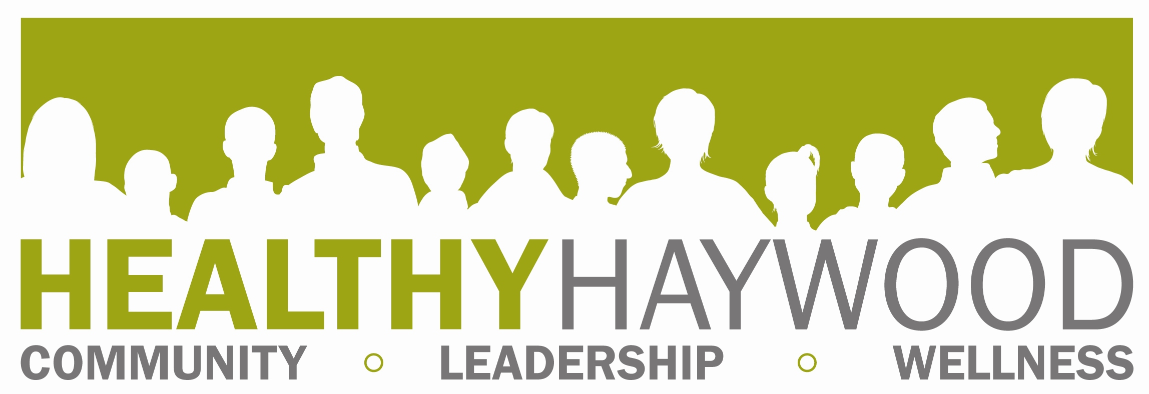

Full Partnership Meeting
Thursday, January 8, 2015
2:00-4:00, Waynesville Recreation Center

Minutes taken by: Megan Hauser

- Welcome and call to order

OLD BUSINESS
- Review of minutes
  - Correction by Jean (clarification: mandatory Controlled Substances Reporting System use didn’t pass; prescribers can designate someone to check system), motion by Paul, second by Patti.
- Introductions- welcome to new members!
- NEW BUSINESS
  - Drugs in Our Midst
    - Pisgah presentation in December- 350 kids, administrators, coaches, Dr. Garrett, Dr. Nolte, 4 speakers. Drug-free pledge cards signed by students.
    - Program planned for Tuscola (want to reach all grades).
    - Working on forming drug-free student group
    - Want volunteers on buses to supervise students
    - Working closely with Mark Sheppard (oversees drug testing, school safety); will be talking to early college about working with DIOM
  - Anonymous People film showing (Smoky Mountain Center-sponsored program)
    - Movie about people in recovery, HART Theater on January 22, movie at 1 (movie also online)
    - Richie working with Governor’s Institute; wants community support
    - Second part is a training; people don’t know how to talk about recovery (those who support them and those who are recovering)
  - North Carolina Coalition Initiative grant
    - Participated in TA call (Megan, Nancy B, Michelle Mathews)
    - Budget amendment approved by commissioners; allows us to make purchases
    - Interest shown in position; please share it with others (health ed/substance abuse); Update: Is now posted on www.ncapha.org. Megan has inquired about having it posted on the county site and sent to all county staff.
    - November site visit went well; NCCI is pleased
    - We’re focusing on adult Rx overdose, looking at root causes
    - Used survey to get data for community assessment (helps us focus on proper substance). Got over 70 surveys
    - Alcohol not seen as problem (easy to get). Rx drugs seen as easiest to get. People are mainly stealing/buying from people they know (want to see decline in these numbers). Have some calls for service data from Sheriff’s Office. Data about Rx problem is in the form of arrest data, death rate. Still need arrest data. Deaths are mostly 40 yr old white males. Still missing some data from examiner (last quarter of 2013). Talk to drug unit for more data.
    - Fewer selling drugs (many arrests), people are arrested for possession, but big focus is dealers. Need jail treatment stats (how many inmates are getting treatment). Meridian is doing groups in jail. Data on effectiveness of treatment programs? Inmates do have to request treatment.
    - NCTOPPS program (mentioned by Patti)- providers enter data. Description from NC DHHS: ‘’NC-TOPPS is a Division web-based system for gathering outcome and performance data on behalf of mental health and substance abuse consumers in North Carolina’s public system of services.’’
    - If CSRS use becomes mandatory, we can possibly get better data about people using Rx drugs.
    - Patti will contact Meridian about getting data; Nancy will contact Appalachian Community Services
    - One concern is drug deals in big parking lots. We propose using additional signage, cameras, work with retailers/employees on what to look for/what to do. Community education and evidence-based strategies needed. What are our timelines for the goals we have in our plan?
    - Next NCCI training is in Asheville in March (17-20). Seeking members to come (even for part of it).
    - We’re seeking members for an NCCI work group
  - Drug task force (opioid prevention)
    - Seeking volunteers (next meeting on 20th at WPD)
    - Led by Dr. Teater (Medical Advisor for National Safety Council)
- Narcan project- project has gone more slowly than hoped. Operates under EMS med director (we work with Jim Pressley). Agency heads are ready for training. Bill Hollingsed is meeting with medical director; discussing drug testing for those arrested. We have some funds for Narcan. (UPDATE: in process of scheduling meeting with EMS, law enforcement and HCC).
  - Fitness Challenge Grant Review Process
    - 3 applications; meeting this month; may just fund one group
    - Have to reserve funds for 2015 challenge
    - We order less materials than in the past due to smaller participation
    - Patti shared about what Mountain Projects was funded for last year
  - American Cancer Society Partnership
    - Community Health Advisor program- need volunteers to educate others, direct them to screenings
    - Community Network Partnership- did breast cancer forums in spring; will be focusing on colon cancer; may work with barber shops to provide education.
    - Interest from Healthy Haywood in focusing on lung cancer; we would need to do this separately from ACS (please provide project ideas)
  - Health Carnival- January 10
    - Signing up for health insurance, HHS building, can help with using marketplace site, 10-2, last people will go in at one, translation services, setting up e-mail, health fair, food, services, Medicaid, can schedule appointments
  - WNC Healthy Kids Grant- promotion of 5-2-1-almost none message, signing MOU soon, getting banners, promoting Appalachian Sustainable Agriculture Program
  - Haywood County Learning Center Partnership and Grant (ALC)- met with staff, need people to provide programming. Programs for students/parents. When spending money, it needs to be evidence-based, substance abuse/healthy living. They have space community meeting.
  - Community Health Improvement Program progress- need to write some articles: illegal drug use, free places to exercise, 521 almost none, signs of heart attacks
  - Other
    - Want to take on other projects? Give ideas and we’ll share it with team.
    - Continued previous discussion about domestic violence and substance abuse
    - Concern about tobacco/nicotine- rates going up, 2013 Youth Tobacco Survey showed increase in males. Paul willing to provide trainings; more now tobacco is being identified as diagnosis; major problems with youth using e-cigs. Spit tobacco use going up; still problems with coaches.
    - If tobacco isn’t addressed, rates go up, we lose federal dollars for prevention/treatment

AGENCY UPDATES/ANNOUNCEMENTS
- Fitness Connection- still have clients from the Fitness Challenge coming
- Eat Smart, Move More Class Cooperative Extension- county staff can come for $10, $25 for others, 15 weeks
- Mountain Projects- now carrying Narcan; one reversal already (needle kits); just call Patti, distributed five so far (ONE REVERSAL!!)
- 30th Alliance- human trafficking awareness month, been doing speaking engagements. Legal Aid will have ‘’second chances’’ program to help victims who have their own charges; they will be coming to the area in March, will also have part-time attorney to help clients (divorce, custody issues); attorney will do clinics throughout region. 30th Alliance has received grant to help children and youth affected by.
- HH featured in a magazine as a volunteer opportunity.

NEXT MEETING: February 12, environmental health conference room, Haywood County Health and Human Services Agency (157 Paragon Parkway in Clyde)

