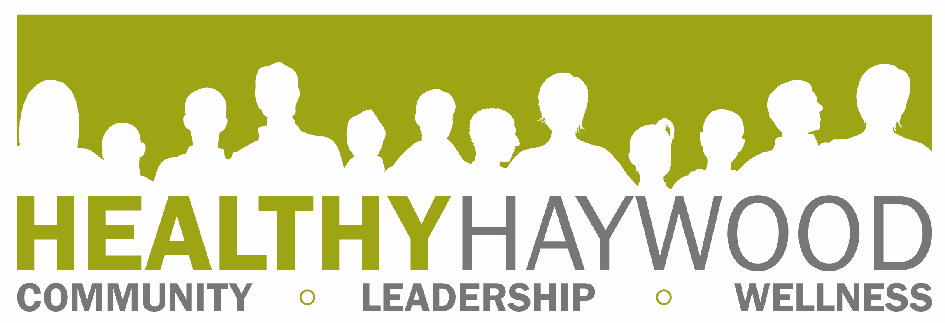

FOR IMMEDIATE RELEASE
Megan Hauser; Healthy Haywood Coordinator
mhauser@haywoodnc.net
828.452.6675
Date: September 3, 2013

2013 Fitness Challenge Begins September 30

The Fitness Challenge will be held again this fall and it’s right around the corner. Beginning September 30, participants can experience a variety of local fitness centers and private businesses offering activity classes up to 24 times over a six week period. Participants can mix and match which centers they want to go to or they can exercise at one place. Registration for the 2013 Fitness Challenge is September 30 through October 4 for only $10. Registration days take place at the following locations and times:

- REGISTRATION – September 30th– October 4th
  - Monday, September 30– Urban Athletic (8am-7pm)
  - Tuesday, October 1 – Cooperative Extension (8am-7pm)
  - Wednesday, October 2 – MedWest Health & Fitness Center (8am-7pm)
  - Thursday, October 3 – Waynesville Recreation Center (8am-7pm)
  - Friday, October 4 – The Fitness Connection (10am-4pm)

The Kickoff event will take place from 5:30-6:30 p.m. on Thursday, October 3 at the Waynesville Recreation Center.

Fitness centers and private business offering activities for this year’s challenge include:
- BODY LYRICS BELLY DANCE
- CROSS FIT HAYWOOD
- FRED RILEY ACADEMY of MARTIAL ARTS
- LEVEL 1 OF 2 FLOW YOGA
- MAGGIE MOUNTAIN FITNESS
- MedWest HEALTH & FITNESS CENTER
- RAQS BELEDI BELLYDANCE STUDIO
- SMOKY MOUNTAIN SK8WAY ROLLER SKATING RINK
- STRICK FITNESS CENTER
- SUEMBA (ZUMBA WITH SUSAN)
- SWEET CIRCLE HOOPS-HOOP DANCING & FITNESS CLASS
- THE FITNESS CONNECTION
- THE OLD ARMORY
- URBAN ATHLETIC TRAINING CENTER
- WAYNESVILLE RECREATION CENTER
- WAYNESVILLE WELLNESS

In recent years, the Fitness Challenge has reached an all-time high regarding participation, which has meant great things for the community - increased physical activity and funds have allowed mini grants to be given away to improve fitness and nutrition within the county. However, this increase has also provided new challenges for the gyms who so graciously donated their time, space and staff, by trying to keep up with the increased volume of people.

This year, Healthy Haywood’s Healthy Living Team and those collaborating with them to bring Haywood County the challenge year after year are challenging participants to make a commitment to themselves to continue their healthy efforts by joining a facility or class after the challenge is over. Overall, it’s the support of those facilities offering their services, equipment and staff that make this challenge possible.

Last year, 1420 people signed up for the challenge. “The main goal of the Fitness Challenge is get people to be more active and eat healthier,” said Megan Hauser, Healthy Haywood Coordinator. “One way we as a community have chosen to tackle this is to promote the abundance of fitness opportunities in Haywood County. This year, we continue to strive for a wide range of fitness opportunities including activities such as belly dancing, martial arts, zumba and dance. We want as many people as possible to experience this opportunity not only for six weeks, but the hope is they will continue these healthy habits for a lifetime.”

Hauser pointed out that in addition to prizes and event promotion, proceeds from the registration fees are used to improve fitness and/or nutrition within the county through a mini grant. Community organizations and individuals who have an idea or project they would like to implement in the county that would encourage fitness and nutrition are encouraged to apply. This year, there will be more competition, because only one grant, instead of several, will be chosen. Guidelines and application are on the website, http://www.healthyhaywood.org/ and due by December 2.

For more information about the Fitness Challenge, go to www.healthyhaywood.org.
Join Healthy Haywood on Facebook and stay updated with Fitness Challenge events. Information about eating smart and increasing physical activity can be found at http://www.eatsmartmovemorenc.com/. Healthy Haywood is a program of the Haywood County Health Department and certified Healthy Carolinians Partnership. You may also contact Megan Hauser at mhauser@haywoodnc.net or 452-6675 ext 2272.

END.

