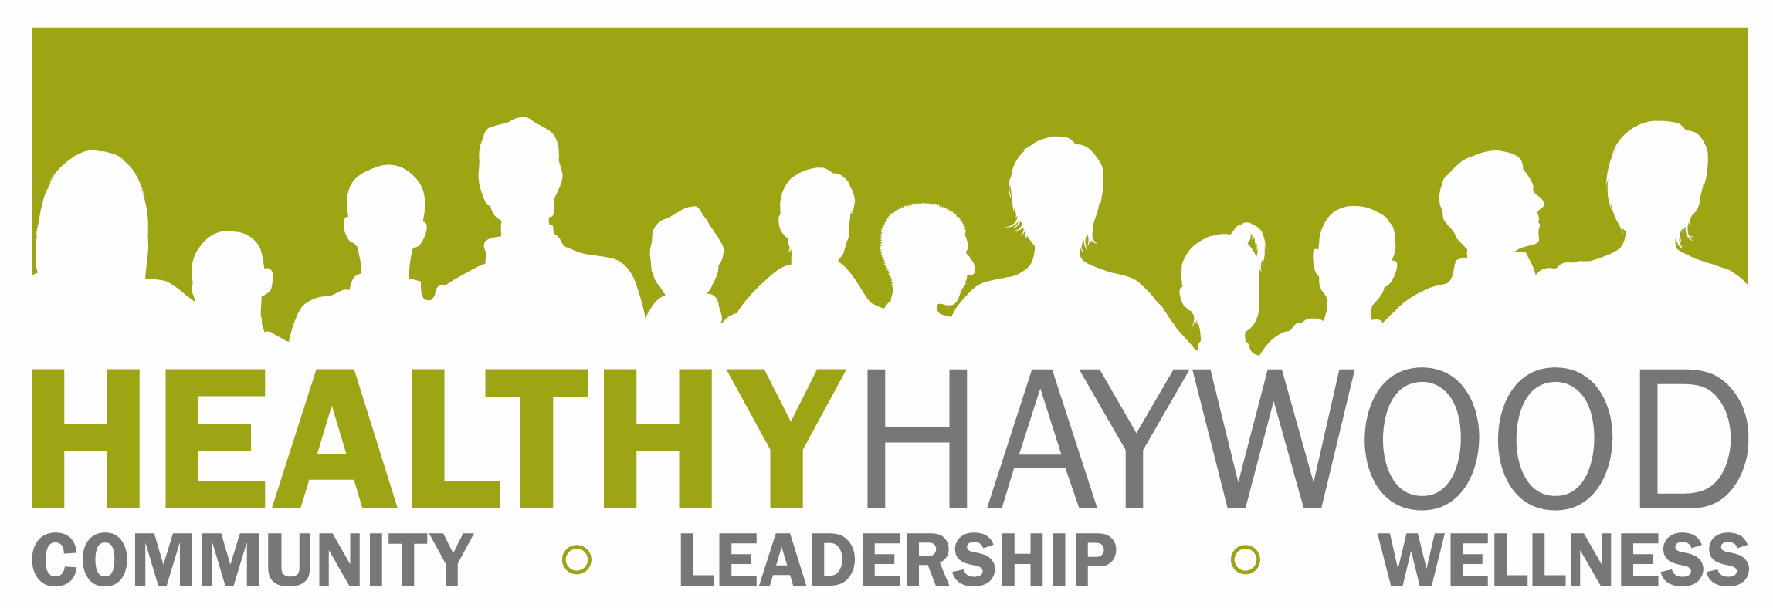

FOR IMMEDIATE RELEASE
Megan Hauser; Healthy Haywood Coordinator
mhauser@haywoodnc.net
828.452.6675
Date: August 21, 2013

2013 Fitness Challenge Begins September 30

The Fitness Challenge will be held again this fall and it’s right around the corner. Beginning September 30, participants can experience a variety of local fitness centers and private businesses offering activity classes up to 24 times over a six week period. Participants can mix and match which centers they want to go to or they can exercise at one place. Registration for the 2013 Fitness Challenge is September 30 through October 4 for only $10. Registration days take place at the following locations and times:

- REGISTRATION – September 30th– October 4th
  - Monday October 1– Urban Athletics (8am-7pm)
  - Tuesday October 2 – Waynesville Recreation Center (8am-7pm)
  - Wednesday October 3 – MedWest Health & Fitness Center (8am-7pm)
  - Thursday October 4 – Cooperative Extension (8am-7pm)
  - Friday October 5 – The Fitness Connection (10am-4pm)

The Kickoff event will take place from 5:30-6:30 p.m. on Tuesday, Oct. 2 at the Waynesville Recreation Center.

Fitness centers and private business offering activities for this year’s challenge include:
- BODY LYRICS BELLY DANCE
- FRED RILEY ACADEMY of MARTIAL ARTS
- MedWest HEALTH & FITNESS CENTER
- JUNALUSKA DRIVING RANGE
- OLD MOUNTAIN HEALTH CENTER
- RAQS BELEDI STUDIO
- SMOKY MOUNTAIN SK8WAY ROLLER SKATING RINK
- STRICK FITNESS CENTER
- THE FITNESS CONNECTION
- THE OLD ARMORY
- URBAN ATHLETIC TRAINING CENTER
- WAYNESVILLE RECREATION CENTER
The final event in this year’s Fitness Challenge will be the fifth annual “Healthy Taste of Haywood”, from 5:30 to 6:30pm on Thursday, Nov. 8. Prizes will be presented at the event. Special thanks to Junaluska Conference and Retreat Center who have donated the space to hold the event at the Harrell Center. “This is the fifth year we’ve had the event and each year it gets bigger and better thanks to participation from local restaurants who have healthy options
on their menu, said Steffie Duginske, Healthy Haywood coordinator.” All Fitness Challenge participants are invited. Fitness Challenge participants are able to sample a wide variety of food from restaurants and grocery stores. During this event, we will demonstrate how to make healthy choices when dining out at local restaurants in Haywood County. Restaurant owners offering health menu options are encouraged to call Steffie Duginske to reserve a space at this event.”

The challenge moved to the fall this year for a variety of reasons. Most importantly, the Fitness Centers who receive the most visits find the fall their “slowest” time of the year. Therefore, equipment, staff, and space will be less occupied, potentially providing more attention to Fitness Challenge members interested in purchasing a membership when the challenge is over. Secondly, the hope is that the shift in season will support improved success as participants move into holiday mode. This time of year we need the most support with the temptations of unhealthy foods and overeating during Thanksgiving and winter holiday parties. Not to mention, colder weather tends to keep us inside, and often times, less physically active.

In recent years, the Fitness Challenge has reached an all time high regarding participation, which has meant great things for the community - increasing physical activity and increased funds have allowed mini grants to be given away to improve fitness and nutrition within the county. However, this increase has also provided new challenges for the gyms who so graciously donated their time, space and staff, by trying to keep up with the increase volume of people.

This year, Healthy Haywood’s Healthy Living Team and those collaborating with them to bring Haywood County the challenge year after year are challenging participants to make a commitment to themselves to continue their healthy efforts by joining a facility or class after the challenge is over. “Overall, it’s the support of those facilities offering their services, equipment and staff that make this challenge possible.

Last year, 2685 people signed up for the challenge. “The main goal of the Fitness Challenge is get people to be more active and eat healthier.” www.eatsmartmovemore.org said Duginske. “One way we as a community have chosen to tackle this is to promote the abundance of fitness opportunities in Haywood County. This year we continue to strive for a wide range of fitness opportunities including activities such as belly dancing, martial arts, zumba and dance. We want as many people as possible to experience this opportunity not only for 6 weeks, but the hope is they will continue these healthy habits for a lifetime.”

Duginske pointed out that in addition to prizes and event promotion, proceeds from the registration fees are used to improve fitness and/or nutrition within the county through a mini grant. Community organizations and individuals who have an idea or project they would like to implement in the county that would encourage fitness and nutrition are encouraged to apply. This year, there will be more competition, because only one grant, instead of several, will be chosen. Guidelines and application are on the website, www.healthhaywood.org and due by December 1.

For more information about the Fitness Challenge, go to www.healthyhaywood.org
Join Healthy Haywood on Facebook and stay updated with Fitness Challenge events.
Healthy Haywood is a program of the Haywood County Health Department and certified Healthy Carolinians Partnership. You may also contact Steffie Duginske at sduginske@haywoodnc.net or 452-6675 ext 2272.

END.

