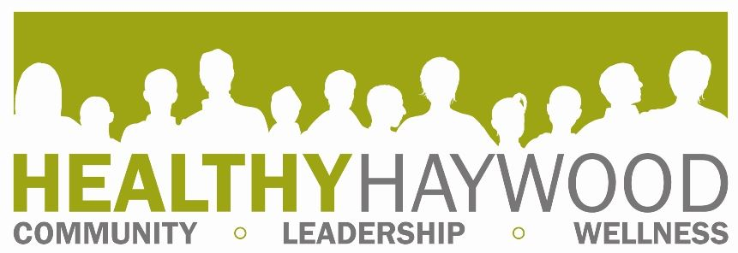

ABOUT OUR PROGRAM

OUR MISSION- To improve the overall health status of Haywood County citizens.

BACKGROUND- We are a program of the Haywood County Health Department and a certified Healthy Carolinians partnership since 1999.

Healthy Haywood consists of a diverse coalition and a Steering Committee. Coalition members are the ‘’worker bees’’ and volunteer at events and/or attend monthly meetings where each member plays a very important role in helping us address the determined health concerns. Steering Committee members meet quarterly and support and guide the organization as a whole.

Based on data collected from Haywood County citizens and current health statistics, health priorities are determined by the community every three years. Various health topics emerge as the coalition grows. The coalition creates an action plan, which includes programs and activities for addressing health priorities. Members also support policies addressing health concerns in the county.

GRASSROOTS APPROACH- Our coalition is not a project, but a process, to bring community members together to focus on health. We believe that community members are the most qualified to prioritize the health concerns in their community and to plan and execute creative solutions.

GETTING INVOLVED- Contact the coordinator to see how you can get started. Attending regularly scheduled meetings is also a good way to see what the coalition is all about. Meeting information listed on our website www.healthyhaywood.org.

PROGRAMS & EVENTS- The following lists just some of the programs we either lead or support:

- Fitness Challenge (Fitness Opportunities & fundraiser to improve fitness & nutrition in Haywood County)
- Healthy Taste of Haywood County
- Power of Pink (funds mammograms for underserved women)

FUNDING- The county funds the coordinator’s position and daily operations. Grants are sometimes written to fund daily operations, program development or a specific project in line with our mission and goals.

CONTACT
Megan Hauser, Program Coordinator, 828-452-6675, ext. 2272
mhauser@haywoodnc.net www.healthyhaywood.org FACEBOOK

